Installing Aluminum Door Panels:

E36 2 Door

Parts, TOols and Supplies Needed
Level of difficulty ●○○○○
Door Panels shipped uncoated bare aluminum. Shown in Black powder coat.
RaceTech Door Pulls (Optional - Sold Separately)
Painters tape, cordless drill, 1/8” drill bit, Philips head driver bit, metal file.
36- #10 x 5/8” or #10 x 3/4” sheet metal screws with captive trim washers (not included¹)
2 – M10 x 25mm bolt, 4 washers, and 2 nuts (not included¹) – Used with RaceTech door pulls.
2 – Wire clamps (not included¹) to hold the door lock rod in vertical position. (Keep from “flopping” around)
¹ Available at local hardware store

Remove oriGinal BMW installed Panels
☐ | Roll down windows
☐ | Disconnect Battery.
☐ | If Driver’s door: remove the mirror switch, disconnect wiring, and set aside to reinstall.
☐ | Remove BMW panels (refer to maintenance manual). CAUTION: Follow instructions to remove airbags if equipped. Moisture barrier can remain installed.
☐ | NOTE: Both Alum. Door panels are interchangeable and can be used on either the passenger or driver side. The passenger side installation is shown in these instructions. Panels shipped uncoated bare aluminum. Shown in Black powder coat.

Install door close strap (Optional)
☐ | RaceTech door pulls are an available option.
☐ | Choose and Mark a position on the door where the pull can easily be reached from a seated and belted position.
☐ | Drill a hole for mounting the door pull.
☐ | Install the Door pull. A M10 x 25mm bolt with washers and nut are used in the example.

Prep and align aluminum door panel
☐ | Secure the door lock knob / rod to the body of the door with a sturdy wire clamp and#10 x 5/8 screw (Drill 1/8” pilot hole for screw). Ensure the rod moves freely and does not bind.
☐ | Driver’s side: NOTE: If a mirror switch will not be installed then do not remove the plug. Remove the material from the pre-cut opening for the mirror switch. Use the metal file to remove any residual material / tab from the opening.
☐ | Position the panel on the door and align. Note: Driver’s side be sure to fish the wire with connector for mirror through its opening.
☐ | Tape the panel securely to the door using painters tape.
☐ | Check the alignment by closing the door ensuring the panel clears the rubber door molding, especially at the front edge, the bottom edges, and around the door handle opening (operate the handle to be sure). Reposition as needed.

Drill pilot holes and install screws
☐ | Using the installed panel as a template drill a 1/8” pilot hole into the door at the top-center position. Check alignment of the panel again.
☐ | Install sheet metal screw to secure the panel to the door. If you find the pilot hole too tight then a slightly larger drill bit may be used to enlarge the hole and to drill the remaining pilot holes. However, using a power drill and driver bit should provide sufficient force to install the #10 screws.
☐ | Using the installed panel as a template drill a 1/8” pilot hole into the door at the bottom-center position. Check alignment and install a screw.
☐ | Drill the remaining pilot holes and install the screws.
☐ | Remove tape then install mirror switch in driver’s side door.
☐ | Recheck that the door lock rod still moves freely. Ensure the door panel is not crushing the clamp. If so, loosen or remove the screw closest to the clamp.
☐ | Reconnect battery.

Photo 1-3: Door Pull Install

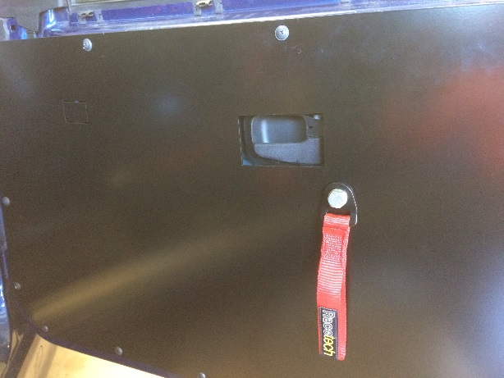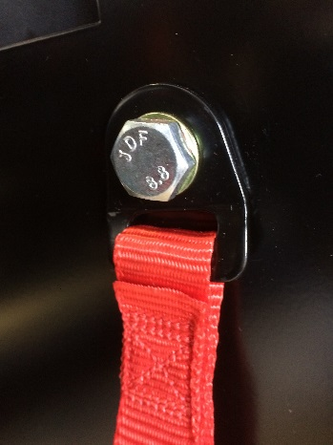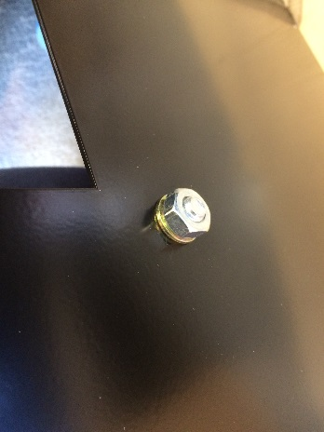

Picture 4-5: Stock Door Panel removed and Details of rod secured
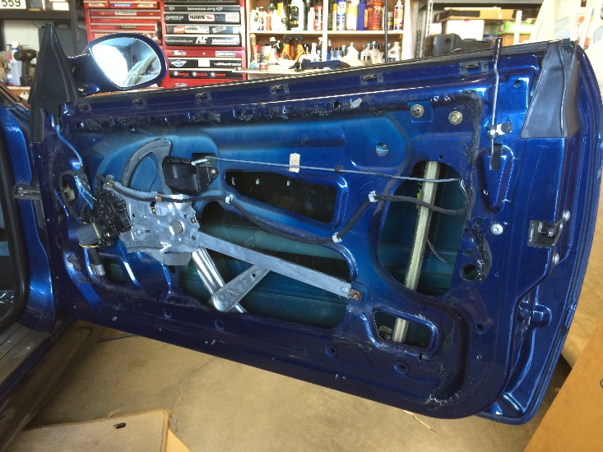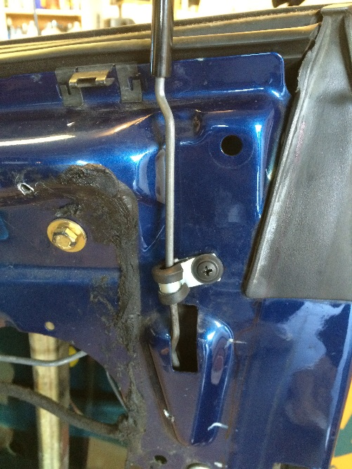

Photo 6: Panel securely held to Door and Aligned
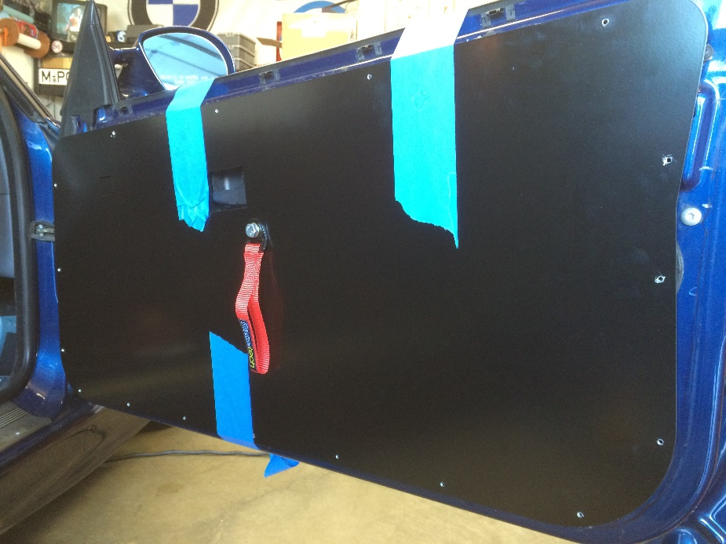

Photo 7: Check Alignment to door rubber molding Photo 8: #10 x 5/8 Trim screw (available in silver)
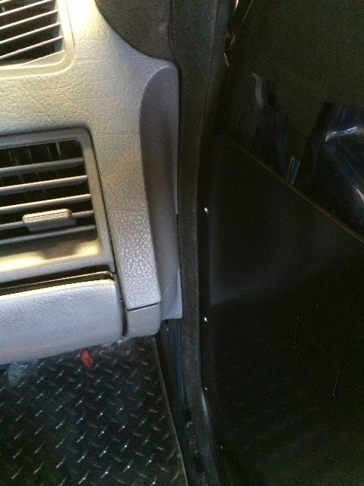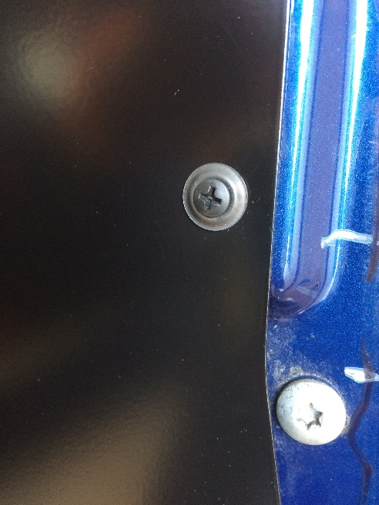

Photos 9 -10: Panels installed. Notice mirror switch.
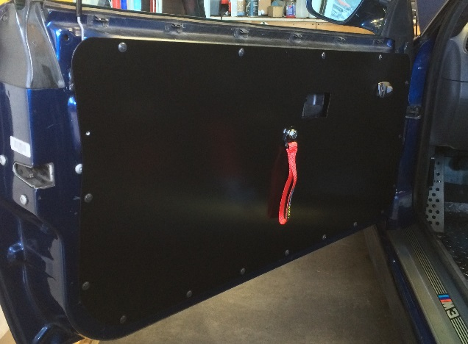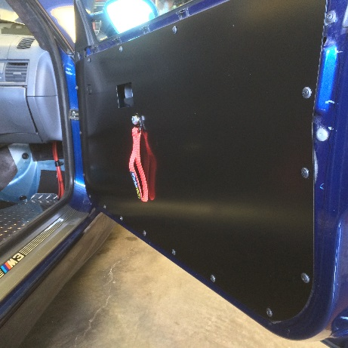

Photo: Finished
